Shade’s Eve – Forest
  - Jordon Trebas

Overview
The goal for this first section of the Shade’s Eve instance is to create a creepy, unsettling mood often not found in MMOs.
- Minimal direction to immediately put players in an unfamiliar position
  - Simple objective: “Escape the forest”
    - Optionals to escape in limited time and avoid Shadelings
  - No quest arrows or map
- Replace all abilities with a limited action bar (see below for more info)
- Jump scares and other frightening imagery:
  - Ghost effects fire when players walk near certain objects
  - Terrifying creatures spawn and quickly despawn around players
- Dark, maze-like forest environment with numerous paths and thick foliage

Gameplay
- Shadelings
  - Some wander around the area
  - If they see the player, they emit a high-pitched screech and run toward it. Players must run away from the Shadeling until it gives up
  - If a player is caught by a Shadeling, they are turned into a Shadeling
- Becoming a Shadeling
  - While a Shadeling, players have access to a unique action bar (see below)
  - Players must consume a “Lost Soul” NPC (they are wandering around the forest) to regain human form
- Player Action Bar
  - Non-Shadeling
    - Flashlight – Lasts a finite amount of time before it must recharge
    - Adrenaline – removes all CC effects. Reusable, but with a long cooldown.
    - Flare – Throw a flare that despawns any non-player Shadelings in the radius. Has a small set number of uses.
    - Flare Gun – Sends a large flare high into the sky that leaves behind a trail. Useful for helping players find each other, but only has a single use.
  - Shadeling
    - Screech – Nearby enemies cry out in fear, making them easier to find
    - Pounce – The Shadeling pounces forward a short distance
    - Devour – Consume a “Lost Soul” to return to non-Shade form
- Environmental Obstructions
  - These are objects that block off certain paths, but they can be opened (possibly only from one side). They act as landmarks through the space and as ways to encourage cooperative play and evade/avoid Shadelings
  - Gates – block off and open certain areas 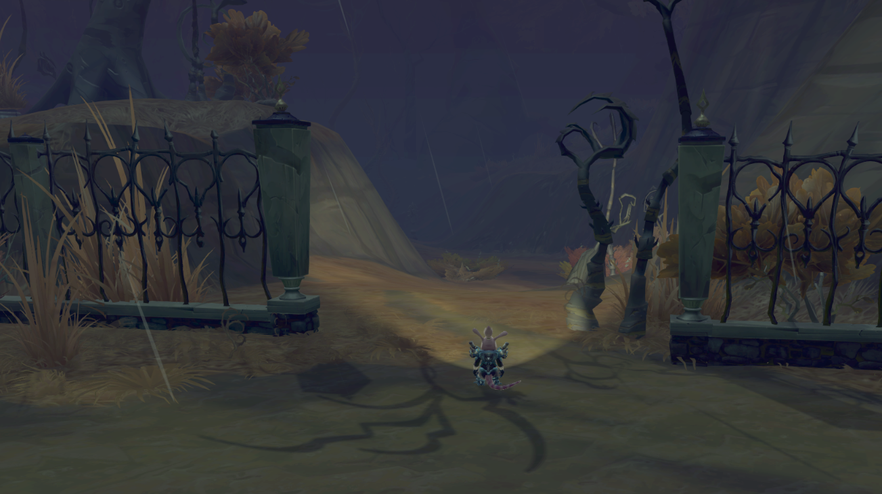
  - Vertical Moving platforms – moves players between different heights 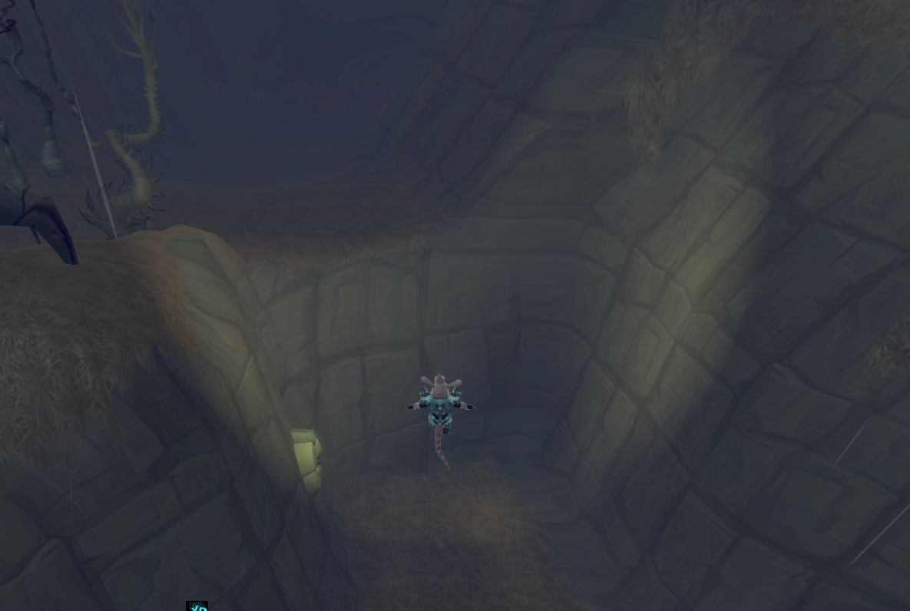

Traps
Aside from the Shadelings, environmental traps are the main feature players must contend with. Each has a visual tell that’s not as obvious as a standard telegraph to encourage replayability throughout the holiday. Players can expect to encounter at least one of each trap type in the forest, with the specific trap spawned at random each playthrough.
- Blind Traps
  - Mysterious Hanging Sack – When players are moderately near this hanging sack, it explodes after a variable delay, blinding nearby players for a long time and summoning a Shadeling .
  - Mysterious Writhing Sack – Players who step on this sack cause it to explode, momentarily blinding nearby players.
- Disable Traps
  - Living Roots – When players enter the bone trap, it snaps shut, disables the player, and has a small chance to summon a Shadeling nearby.
  - Beast trap – Well-hidden traps that snap shut when players walk on them, disabling them for a short time. When activated, it has a small chance to summon a Shadeling nearby.
  - Motion Detector – Players who enter into the area of the trap are suspended mid-air for a brief time while a Shadeling has a chance of spawning nearby
- Disorient Traps
  - The Mist – Persistent mists that move around the environment, disorient players for as long as they are inside them
  - Toxic Mushrooms – small mushrooms that, when walked on, have a small chance to explode and release a toxic cloud in the area. Players affected by the toxin are disoriented for a short time.
- Mystery Interactive Objects
  - Suspicious Cage – Can be activated while it’s rocking back and forth. Once activated, it opens to reveal a supply crate, a Shadeling, or nothing.
  - Unburied Casket – A casket that can be opened to reveal a supply crate, a Shadeling, or nothing.
- Slow Traps
  - Ghost field – spectral apparations that briefly appear and disappear around the environment. Players who encounter a ghost field will be haunted by a ghost for several seconds, slowing their movement substantially.

