Pre-Tutorial Design Doc
  - Jordon Trebas

Overview
The purpose of the pre-tutorial is to act as an entry point to players who are completely unfamiliar with standard MMO conventions. This means a completely non-lethal environment that guides players through the basics of navigating through an MMO.

Theme
The pre-tutorial takes place in a simulation of sorts as players begin the process of awakening from cryosleep. An AI guides the player through the experience of ensuring their vitals haven’t been damaged from the extended time in cryo.
The area would look similar to the Animus of Assassin’s Creed with open spaces and a simple color palette so we can easily draw the player’s attention.
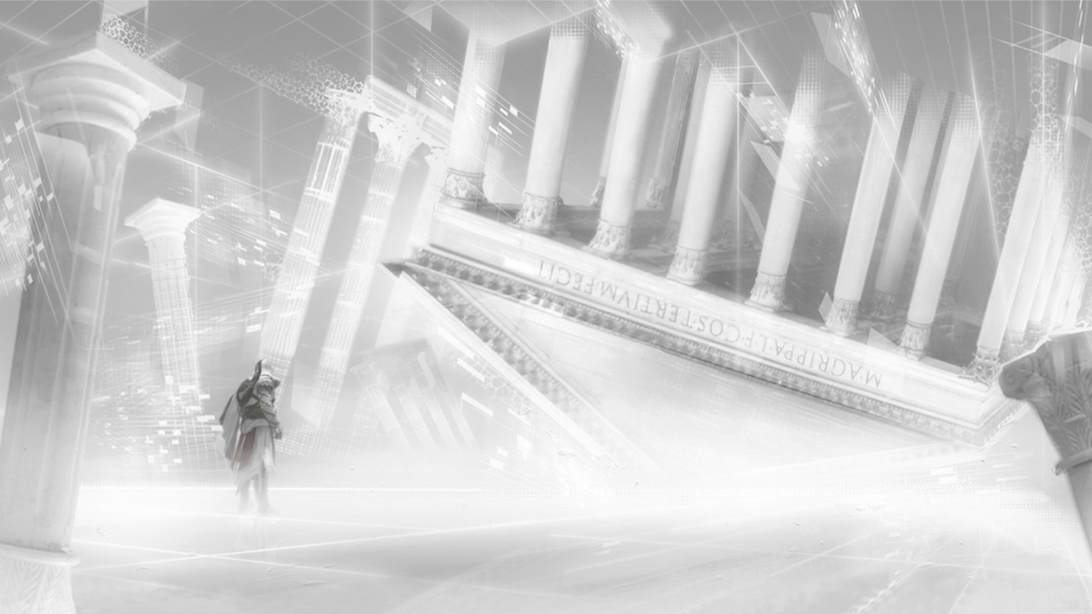

Area Breakdown
One of our primary goals is to present players with easily digestible chunks of gameplay without confusing them with extraneous information. We plan to accomplish this with simple objectives, phasing, and a measured rollout of the UI.

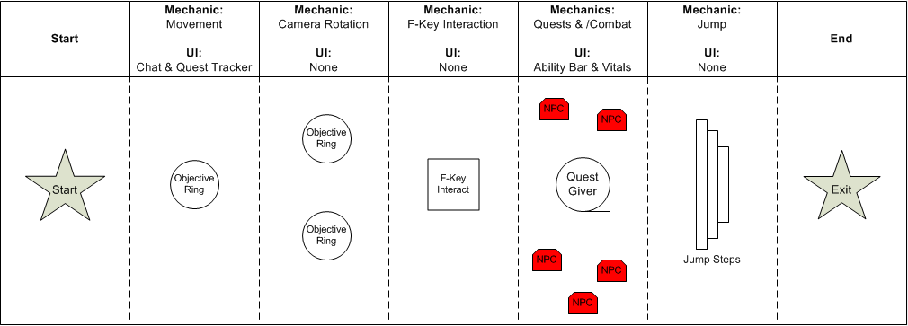

Figure 1 - Each section would exist in its own phase (designated by the dotted lines)

Objectives
Each objective focuses on teaching a single mechanic by forcing players to use that mechanic to proceed. Before players receive their quest in the fourth objective, they are guided both by comm calls and a public event for each section that acts as a simple text guide for players (without overloading them with information about receiving/turning in quests too early).
- Walk into the first objective ring
- Rotate the camera to move into the next two rings
- Activate an object
- Receive a quest from an NPC
- Kill the critter NPCs
- Jump to reach the exit

Phasing
Each section of the map takes place in its own phase, with the player transitioning between these phases. When players complete an objective, new barriers appear to prevent them from backtracking while other barriers disappear to lead players on to the next objective. In addition, players only see other players who are working on the same objective as them. This way, players stay focused on the current objective and don’t get lost.

UI Rollout
Our full UI is incredibly distracting and confusing for new players. If we are truly gearing this toward players who are unfamiliar with standard MMO conventions (of which a complex UI is one), then we must roll out the UI the same way we roll out mechanics. Players begin with only the chat box and quest tracker available, and the ability bar and player health bar is added on later. Once the Arkship begins, the entire UI appears (although players will always be able to access the various menus through hotkeys).

