Wildstar One-year Anniversary

Overview
To celebrate Wildstar’s one-year anniversary, we will be giving away several unique items to players who log in during the month of June 2015. The theme of the event is celebration, and we want to give something that can benefit the various types of players.

Rewards
Players will receive a loot box that can be salvaged to give them 5 unique items:
- Title
  - “[Name], The Wild Star”
- Stack of 10 Consumable Items
  - “Party of One” – Creates an instant party around the player with balloons, streamers, and lights.
- Vanity Pet
  - “Party Dawngrazer” – A miniaturized Dawngrazer topped with a festive hat on its head.
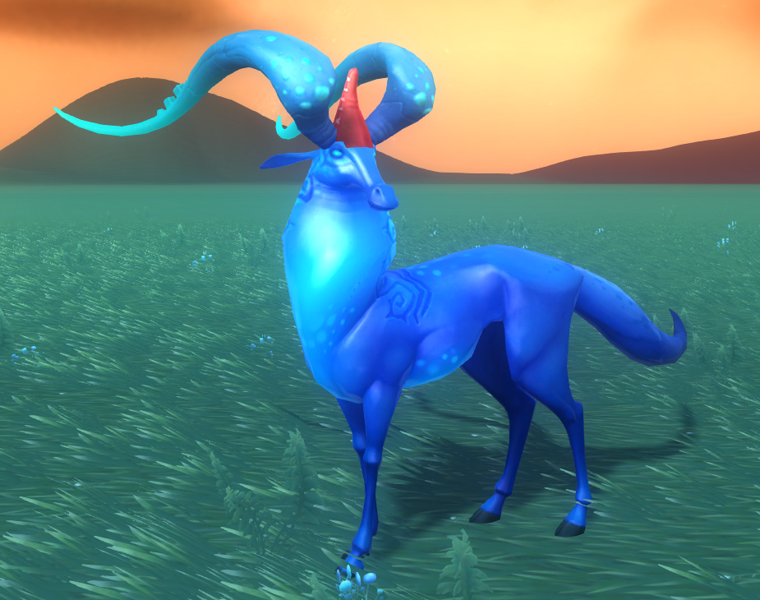
- Housing Décor
  - “Anniversary Cupcake” – A large cupcake that players can place in their homes and interact with. When activated, the unlit candle on top of the cupcake lights up with great fanfare.

- Toy
  - “Boom-Box” – A reusable item that places a Boom-Box at the spell’s location. That Boom-Box can then be activated to cause that player to dance uncontrollably for 30-60 seconds while music plays in the background.
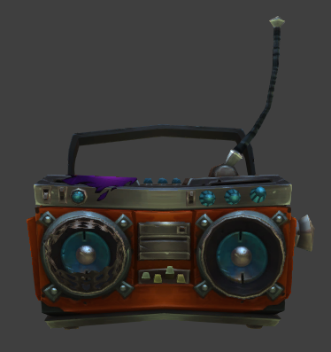

Other Potential Rewards
All of the previously listed items have no impact on gameplay, but we could also include an additional item that players usually work toward to improve their characters. Something like a currency token or even an additional amp or ability point could incentivize players who are not as interested in vanity items to come back during the celebration.
In addition, we could include a brief note to give the gift some context within the narrative of the game. This could either be as a standalone note item or in the loot box item description.

Tasks
- Design
  - Loot box container item – 1 hour
  - Title item & spell – 1 hour
  - Consumable item & spell – 4 hours
  - Vanity pet item & spell – 2 hours
  - Housing décor item & spell – 6 hours
  - Toy item & spell – 8 hours
- Art
  - Cupcake prop
  - Balloon/Streamers recolor
  - Party Dawngrazer hat
  - Cupcake second anim state & transition
  - Party Dawngrazer skin
- Engineering
  - Item Distribution
- Narrative
  - String Review
- Localization
  - 6-7 Item names and descriptions
  - 3 Spell names & tooltips
  - 1 Achievement name & description

